**Creating IBM Catalog Sources**

Adding catalog sources to your OpenShift cluster adds the IBM operators to the list of operators you can install.

This task must be performed by a **cluster administrator**.

To add the catalog sources to your cluster, you use one of the following sources:

Specific catalog sources for each operator

The IBM Operator Catalog

Applying individual catalog sources allows full control of software versioning on a cluster. This allows administrators to:

upgrade each Cloud Pak component independently.

have a fully declarative set of artifacts to recreate exact installations.

easily control the upgrade and promotion through environments with a CI/CD pipeline.

remove the usage of manual approval settings on operators which should not be used. With catalog source control, the upgrade can only happen when the specific image digest for the specific catalog source is changed.

**Section 1: Verify: IBM Operator Catalog**

1. Let’s verify if **ibm-operator-catalog** has been installed. To do that goto **Administration** and click **Cluster Settings** and click the tab **Configuration**. And search for **operatorhub** in the filter box. Click on the Configuration resource **OperatorHub**.

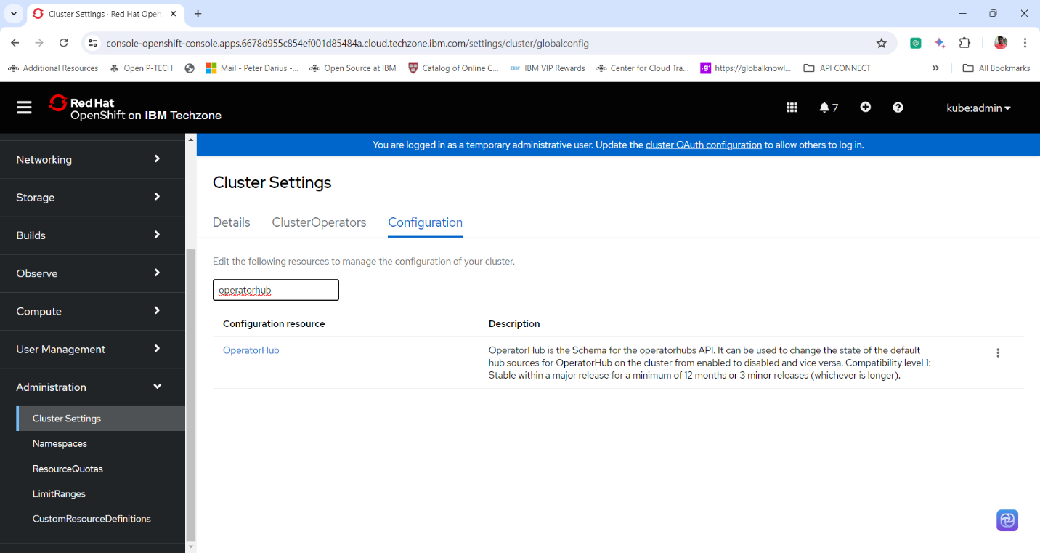

2. Verify if **ibm-operator-catalog** has been deployed, if not follow the procedure to deploy the same.

**Section 2: Using the OpenShift web console**

1. Log into the ***OpenShift Web Console*** with your OpenShift Cluster Administrator Credentials.

2. Follow the link to copy the code to create the IBM Catalog Sources.

<https://www.ibm.com/docs/en/cloud-paks/cp-integration/2022.2?topic=images-adding-catalog-sources-cluster>

apiVersion: operators.coreos.com/v1alpha1

kind: CatalogSource

metadata:

name: ibm-operator-catalog

namespace: openshift-marketplace

annotations:

olm.catalogImageTemplate: "icr.io/cpopen/ibm-operator-catalog:v{kube_major_version}.{kube_minor_version}"

spec:

displayName: IBM Operator Catalog

image: 'icr.io/cpopen/ibm-operator-catalog:latest'

publisher: IBM

sourceType: grpc

updateStrategy:

registryPoll:

interval: 45m

3. In the banner, click the **plus ("+")** icon to open the **Import YAML** dialog box.

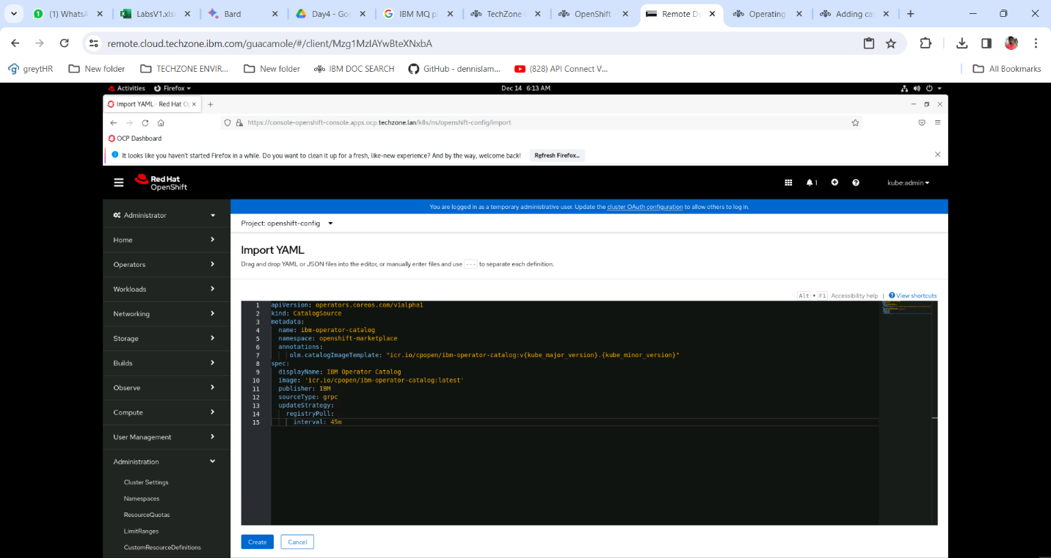

**Note:** You do not need to select a value for "Project". The YAML in the next step already includes correct value for metadata:namespace, which ensures the catalog source is installed in the correct project (namespace).

4. Paste this resource definition into the dialog box:

apiVersion: operators.coreos.com/v1alpha1

kind: CatalogSource

metadata:

name: ibm-operator-catalog

namespace: openshift-marketplace

annotations:

olm.catalogImageTemplate: "icr.io/cpopen/ibm-operator-catalog:v{kube_major_version}.{kube_minor_version}"

spec:

displayName: IBM Operator Catalog

image: 'icr.io/cpopen/ibm-operator-catalog:latest'

publisher: IBM

sourceType: grpc

updateStrategy:

registryPoll:

interval: 45m

5. Click **Create.**

**Section 3: Check if IBM Catalog Sources are created.**

1. Expand **Administration** menu and click **Cluster Settings**.

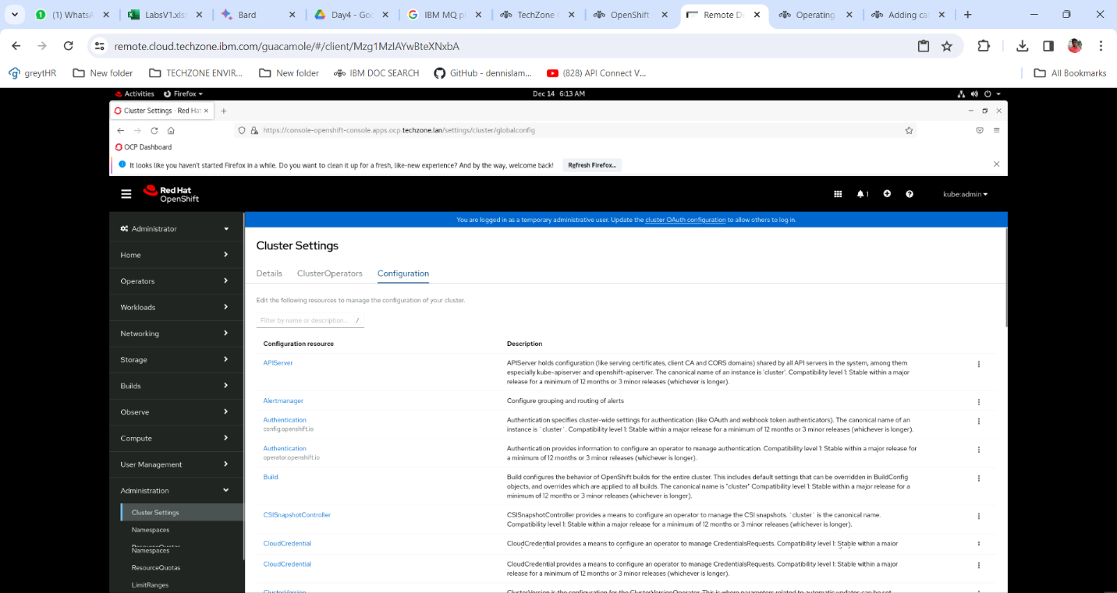

2. Click on the **Configuration** Tab and Search **OperatorHub** and Click on the same.

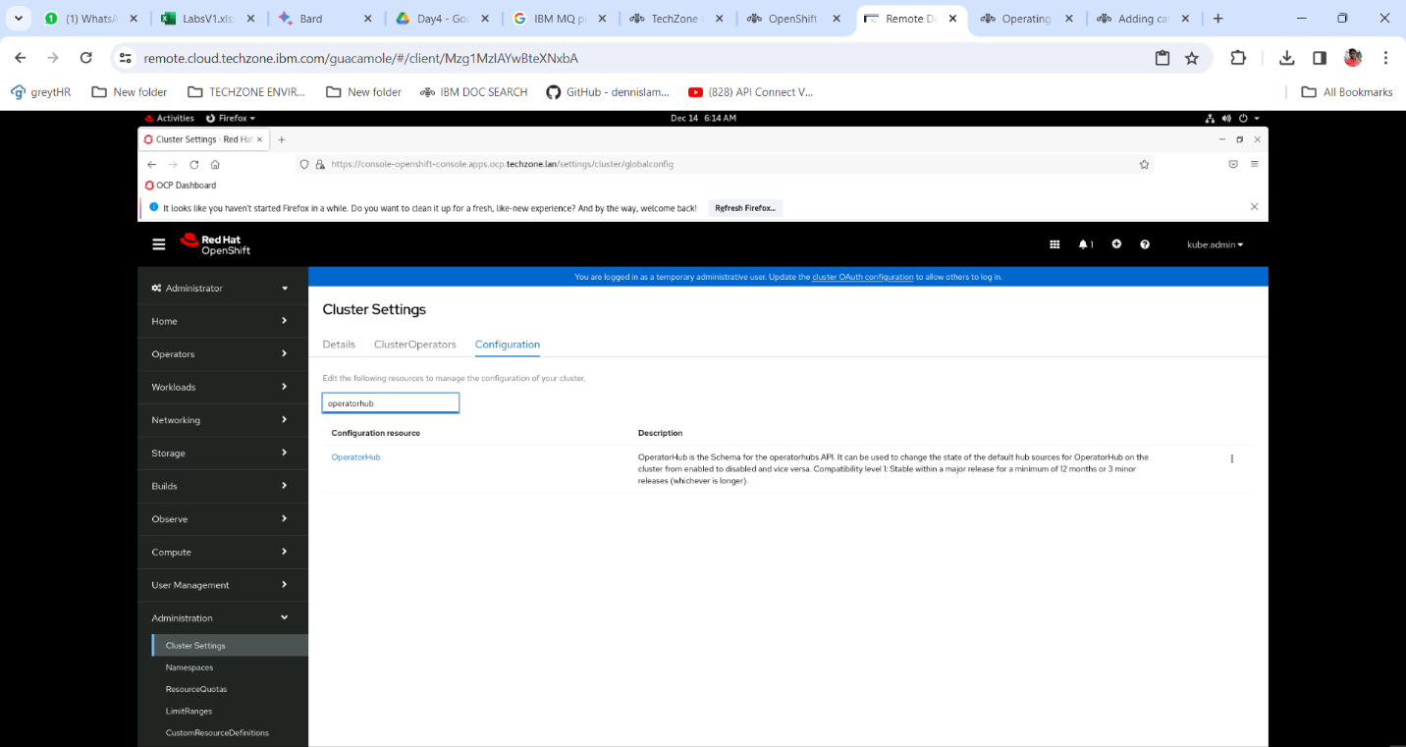

3. In the **OperatorHub** window click on the tab **Sources** and check if **ibm-operator-catalog** catalog sources are loaded.

